Project Design Phase-II
Data Flow Diagram & User Stories

Date
Team ID | SWTID-2026-7196
Project Name | AI-Weatherwise
Maximum Marks | 4 Marks

Data Flow Diagrams:
A Data Flow Diagram (DFD) is a traditional visual representation of the information flows within a system. A neat and clear DFD can depict the right amount of the system requirement graphically. It shows how data enters and leaves the system, what changes the information, and where data is stored.

Example: (Simplified)


Data Flow Diagram: AI-Weatherwise (Level 1)
Registered users, public weather users and admins interact with the Express API. Requests flow through Authentication, Location Management, Weather Retrieval, AI Insights and Admin Management. Users and locations are stored in MongoDB; live weather comes from OpenWeatherMap and summaries and recommendations come from Google Gemini.
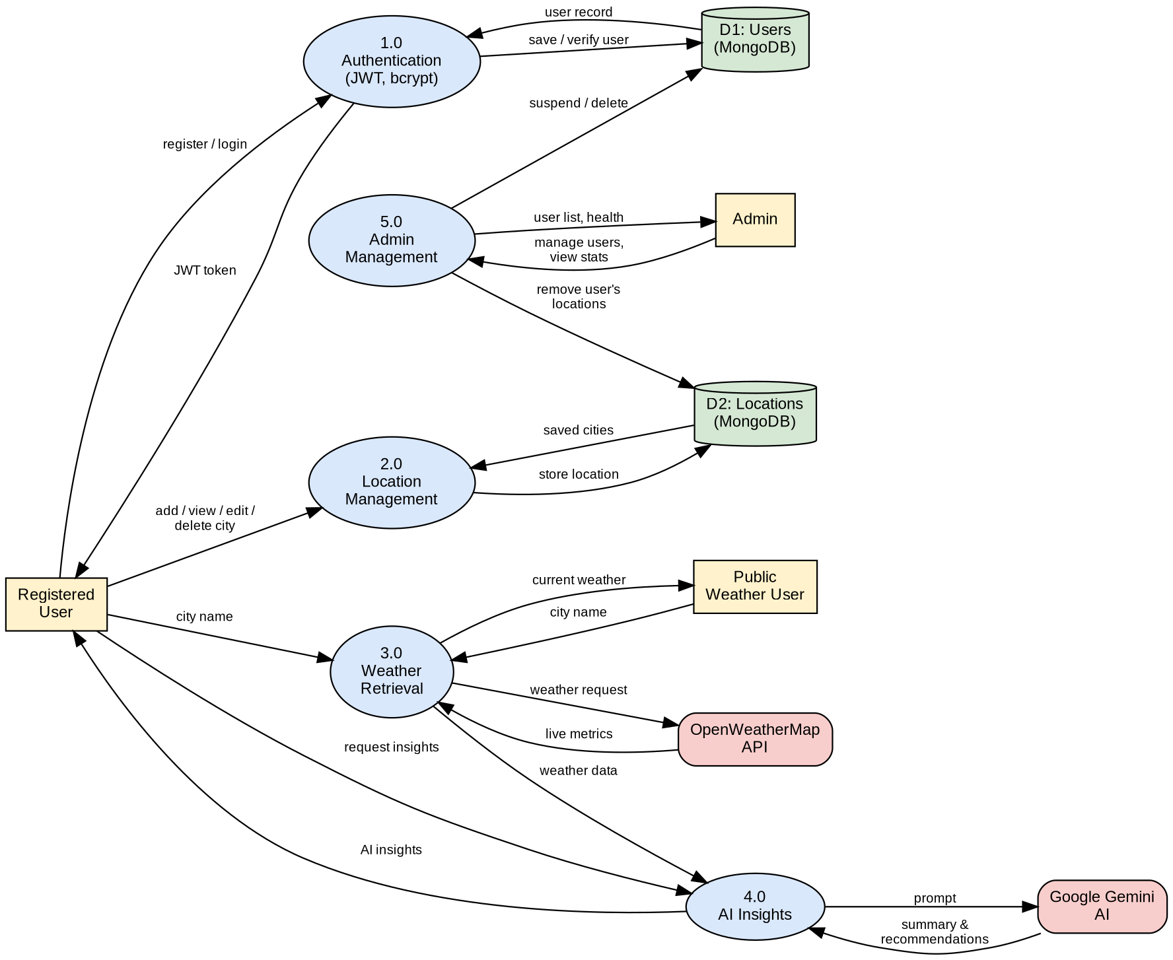

User Stories
Use the below template to list all the user stories for the product.
User Type | Functional Requirement (Epic) | User Story Number | User Story / Task | Acceptance criteria | Priority | Release
Registered User | Registration | USN-1 | As a user, I can register by entering my name, email and password. | Account is created and I receive a JWT token | High | Sprint-1
Registered User | Registration | USN-2 | As a user, I want my password stored securely so that my account stays safe. | Password is saved hashed (bcrypt), never as plain text | High | Sprint-1
Registered User | Login | USN-3 | As a user, I can log in by entering my email and password. | I receive a JWT token and can access protected endpoints | High | Sprint-1
Registered User | Login | USN-4 | As a user, I can update my profile name and password. | Updated details are saved and returned | Medium | Sprint-2
Registered User | Favourite Locations | USN-5 | As a user, I can add a favourite city with its country. | City is saved under my account | High | Sprint-1
Registered User | Favourite Locations | USN-6 | As a user, I can view all my favourite cities. | List shows only my own locations, newest first | High | Sprint-1
Registered User | Favourite Locations | USN-7 | As a user, I can update or delete a favourite city. | Changes are saved; a missing city returns Location not found | Medium | Sprint-2
Registered User | Weather | USN-8 | As a user, I can fetch the current weather for a city. | Temperature, humidity, wind and condition are shown | High | Sprint-1
Registered User | AI Insights | USN-9 | As a user, I can get a natural-language weather summary for a city. | A readable summary generated by Gemini is returned | High | Sprint-2
Registered User | AI Insights | USN-10 | As a user, I can get clothing and outdoor activity recommendations. | Personalised recommendations based on live conditions are returned | High | Sprint-2
Registered User | AI Insights | USN-11 | As a user, I still get results when API keys are unavailable. | Fallback weather and built-in text are returned (source: fallback) | Medium | Sprint-2
Weather Application User (Public) | Weather | USN-12 | As a visitor, I can view current weather without creating an account. | Weather is returned without a token | High | Sprint-1
Administrator | User Management | USN-13 | As an admin, I can view all registered users. | User list is returned without passwords | High | Sprint-3
Administrator | User Management | USN-14 | As an admin, I can suspend or delete a user. | Suspended users cannot log in; deleted users and their locations are removed | Medium | Sprint-3
Administrator | Monitoring | USN-15 | As an admin, I can check API health and system statistics. | Health status, user count and location count are shown | Medium | Sprint-3

